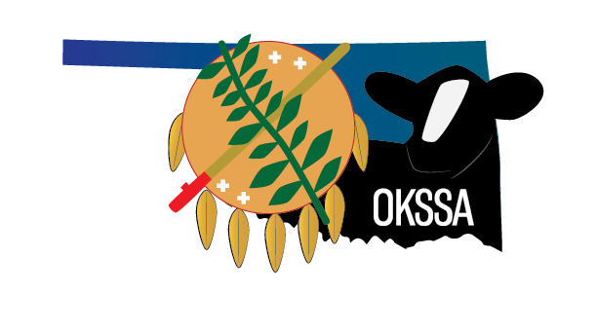

Meeting Agenda
Location: | Conference Call  (253) 205-0468  Meeting ID: 580 366 9260
Date: | August 6, 2023
Time: | 2:00 p.m.

Welcome & Call to Order—President, Kurt Hamburger

Minutes—Secretary/Treasurer, Angela Landwehr

Review/Amend/Approve Prior Meeting minutes

Financial Report—Secretary/Treasurer, Angela Landwehr

Review of Financial statements

Review and approval of any expenses

Committee Reports

Executive Committee Report

Annual Meeting—Michelle Helm, Executive Secretary

Fairs/Shows/Sale Committee Report
c. Nominating Committee Report
d. Membership/Promotion Committee Report
e. Youth Activities Committee Report
i. Update on 2023 National Classic—Danae Ison, Junior Advisor
f. Performance Committee Report
i. Results of Sale Survey—Michelle Helm, Executive Secretary

Unfinished Items to Discuss

Proposed By-Law Changes—Michelle Helm

2022 Membership Directory invoices—Michelle Helm

Sponsorship of Added prize money at TSF--$250 for Grand Champion and $150 for Reserve (Purebred and Percentage)=Total of $800

Presentation of Junior of the Year revised application—Michelle Helm

New Items to Discuss

Proposed Open show at Oklahoma State Fair—Jeff Henrichs

Announcements

Adjournment

